Programming Assignment 2

In this assignment, you’ll modify the Tip Calculator app so that it uses a seek bar instead of two buttons to set the tip percent. When you’re done, a test run should look like this:

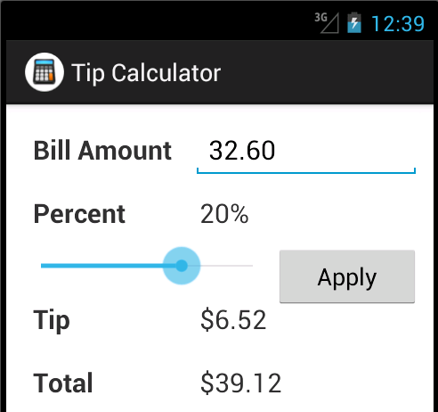

Test the app

1. Start Android Studio and open the project named ch05_ex3_TipCalculator (PA2 Starter Code).
2. Test this app to see how it works. Note that the Apply button doesn’t do anything.

Add a seek bar

1. Open the layout for the activity and delete the two buttons that set the tip percent.
2. Create a new row below the “Percent” row that consists of a seek bar followed by the Apply button as shown above.
3. The seek bar should have a maximum value of 30 and a default progress of 15.
4. Open the class for the activity and delete all code related two the two buttons that have been deleted.
5. Modify the calculateAndDisplay method so it gets the correct tip percent from the SeekBar widget and displays the correct tip percent on the related TextView widget.
6. Test this change to make sure it works correctly. Note that you must click the Apply button to display the new tip percent that has been set by the seek bar. Although this seek bar should work, it doesn’t provide a responsive user interface. That’s why the next chapter shows how to handle the events of a seek bar to provide a more responsive user interface.